**Exercise 2 : Financial Forecasting**

**📌 Implementation**

**🖩 Logic / Formula:**

* **Recursive Approach:**  
  To calculate future value, we use the formula:  
  **futureValue = currentValue × (1 + growthRate) ^ years**  
  Recursion helps by repeatedly multiplying the current value by *(1 + growthRate)* for each passing year.

**⚙️ How It Works:**

1. The **futureValue()** method repeatedly calls itself, increasing the value by the growth factor and decreasing the number of years one by one.
2. When the number of years becomes **0**, the method stops calling itself and returns the final value.
3. The final result is then displayed through the **main()** method.

**🡪Code :**

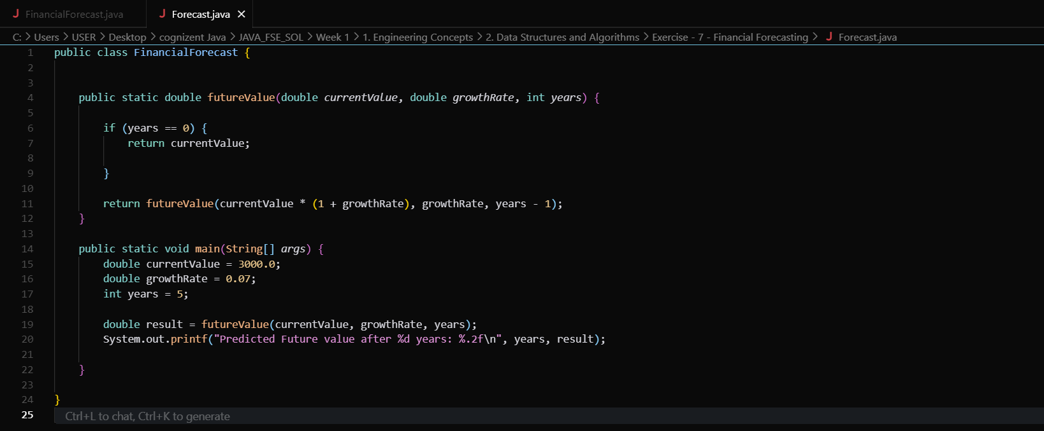

* **Output :**



🡪**Analysis**

* **Time Complexity:** O(n) , where n is the number of years
* **Optimization :** For large n, use iterative approach to avoid stack overflow and repeated calculations.